**TO WHOM SO EVER IT MAY CONCERN**

This is to certify that **Mr.Prince Pal s/o Sh.Vijay Kumar** Pursuing MCA-VI Semester from **Kurukshetra University** program is under going for Six Month Training at **Levycon India (OPC) pvt Ltd** from **14.01.2021 to 20.07.2021.**

During his training program, he familiarized himself with the operations/functions of various departments of our company. He is special flair of IT Industry and took keen interest in learning new aspect of Software and Mobile Application Development. He has completed the assigned project named **“ Smart City” in PHP Platform in the month of May 2021.After this he will be assign other Website of Food Delivery by our company which will be completed by July 2021.**

During his training, he is availing himself of all possible opportunities for harmonious development of his personality. We found him intelligent, hardworking and punctual. We wish him all the success in pursuit of his academic achievements and professional career.

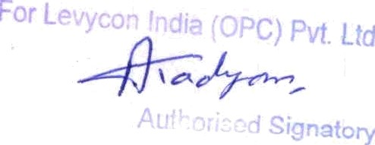

Place: Gurgaon

Date: **Authorised Signatory**

**Levycon India (OPC) PvtLtd**